Assignment-Digital Marketing

Name | Mugesh R
RegNo | 962820106308
NM ID | 7A1642A7F8CA425AB874AB65B2D213DA

Blog link:https://shoehub4.wordpress.com/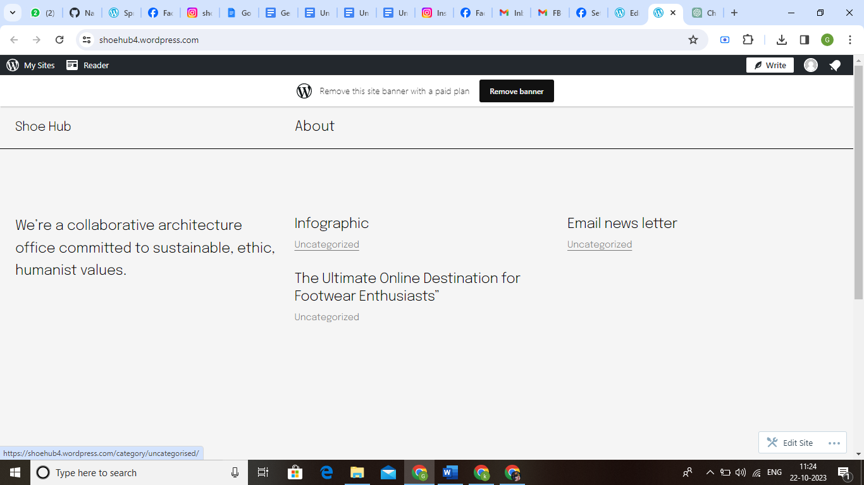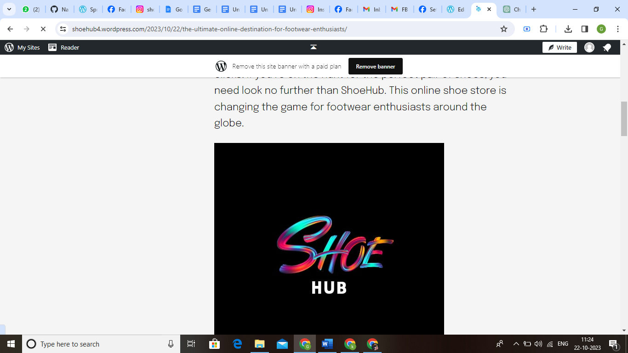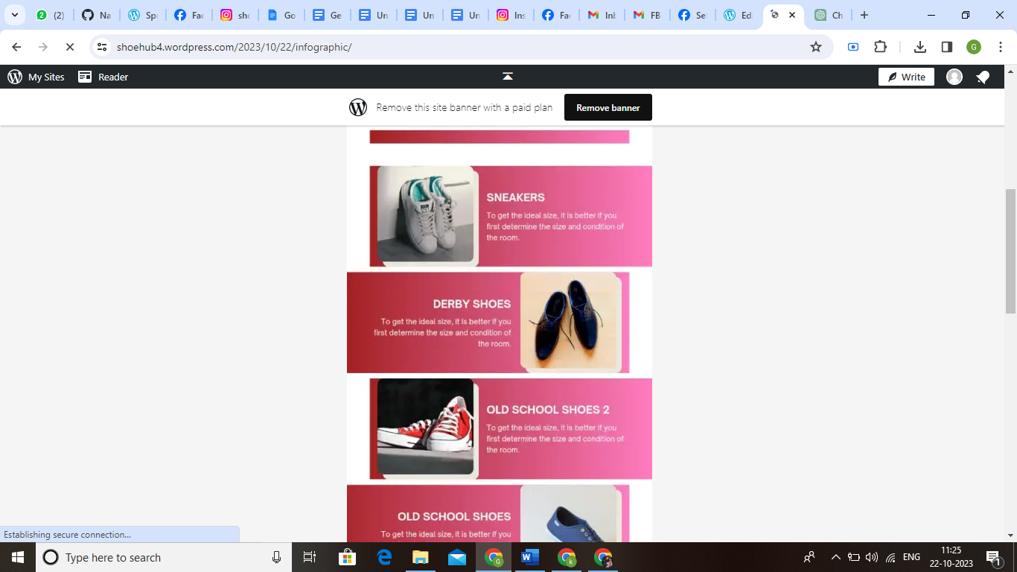

Facebook page link:https://www.facebook.com/shoehub390
